User Guide

Brainvire

Contents

User Guide 2

# User Guide

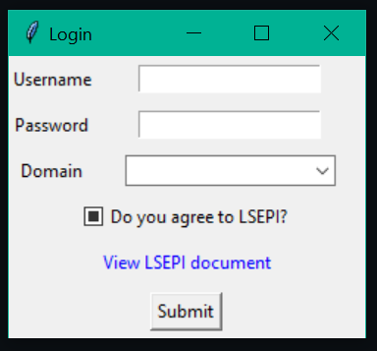

When the program starts it will ask the user for a username, password, domain and if you want to agree to the LSEPI.

This is so that correct username and password must be working correctly so that if incorrect username or password is typed it will not allow entry.

Also, the user must agree to the LSEPI document so that they agree with on our terms to login.

When the user clicks the text “view LSEPI document” it will open a web browser to display the LSEPI document.

When all these their factors are met the user can then press the submit to login.

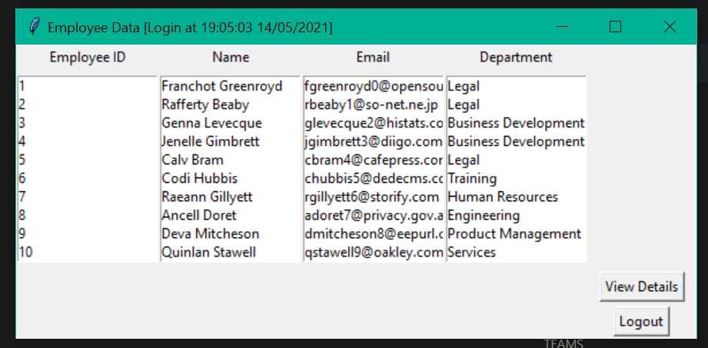

This is the screen that displays when the user successfully logs in to the program it will display the database file in to the correct listboxes also the user can log out via the button and view details.

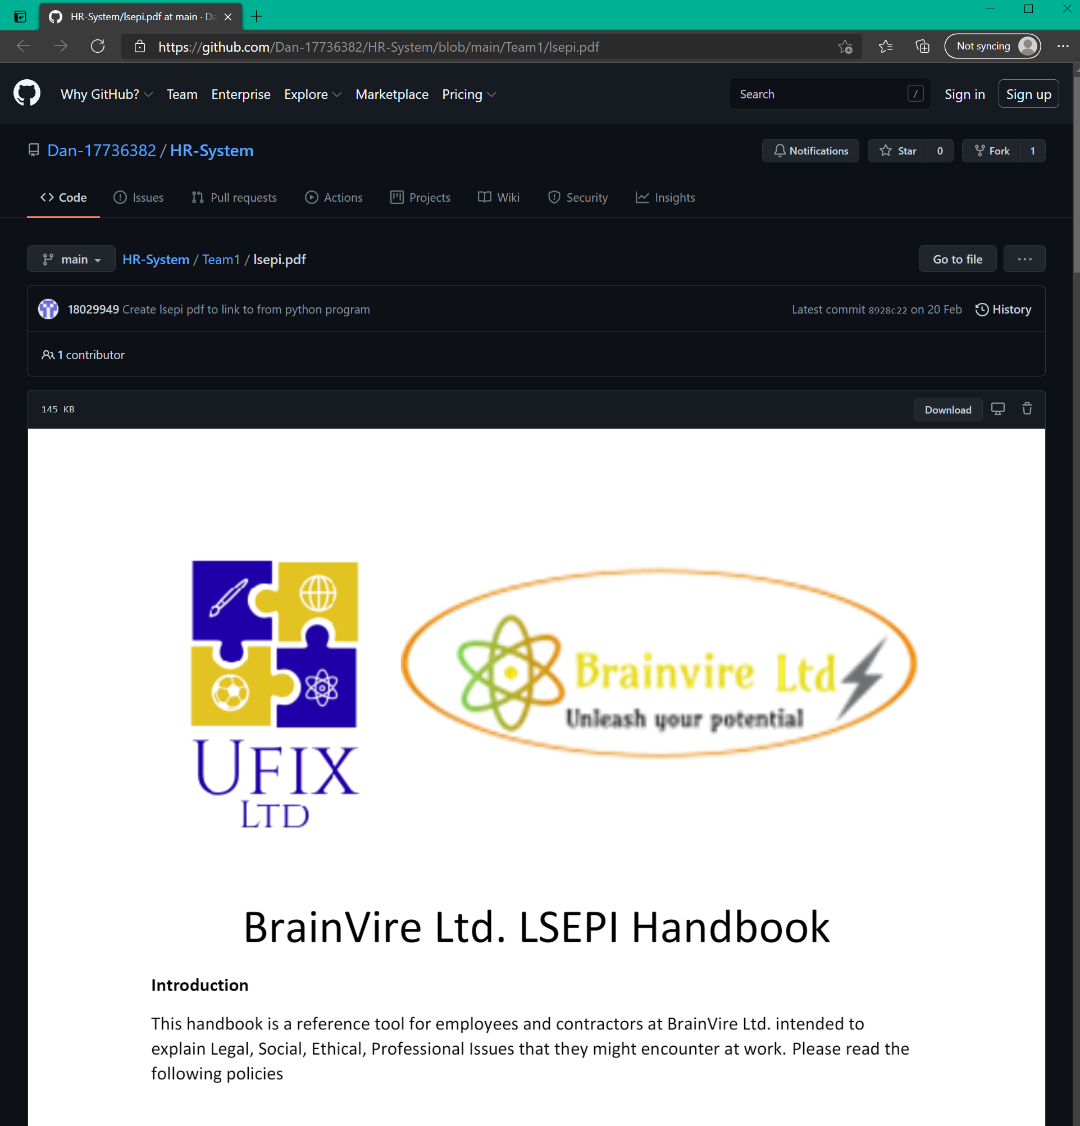

This is the LSEPI link for document that will be displayed.